**Media Studies**

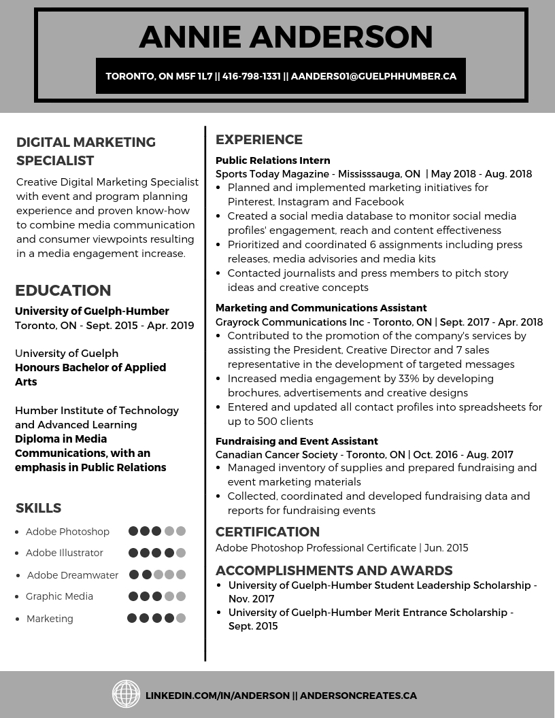**Resume Sample**

**Need more help?** Visit Career Services in GH108 | Call: 416-798-1331 ext. 6288 | Email: [career@guelphhumber.ca](mailto:career@guelphhumber.ca) | Job and Placement Portal: ghworks.guelphhumber.ca